Work to be done:
- Open a new WORD document.
- Name your file Business Letter. Click Save.
- Margins: all 1”. Line Spacing: Single
- Times New Roman, size 12, no bold or italic
- Compose your letter of complaint
a. Heading:
i. Your Address: Use Pathways address-ENTER-then ENTER-then Date
ii. Recipient’s Name or Title of who you want to receive letter (i.e. Jim Smith), ENTER, Title Manager, ENTER, Company Name, ENTER and Address: Use a restaurant or other place of business you have visited and have a complaint about—if you don’t have a real complaint—INVENTONE
b. Salutation
c. Body: 3 paragraphs
Paragraph 1: Introduce yourself and the facts of your visit-ENTER/ENTER
Paragraph 2: What product or service you are complaining about-ENTER/ENTER
Paragraph 3: A positive statement, ask for some kind of action, thank the person for their time-ENTER/ENTER
d. Closing-ENTER/ENTER/ENTER
e. Signature-Type Your Full Name
FORMATTING Directions (Parts of a Letter)
1. Heading
• Contains your return address and the date Located at the top right of the letter
• Contains recipient’s name, job title, company name, company address—justified left
2. Salutation
• Example: Dear ____________
• For a Friendly Letter, end with a comma
• For a Business Letter, end with a colon
3. Body
• For a Friendly Letter, indent all paragraphs
• For a Business Letter, align paragraphs with your Salutation (left alignment)
4. Closing –
• Example: Sincerely,
• End with a comma
• Align with your Heading (left alignment)
5. Signature
• Lined up with Closing and Heading (left alignment)

This format is just a guide. Variations and customizations are common. Want to download this sample without the graphics?
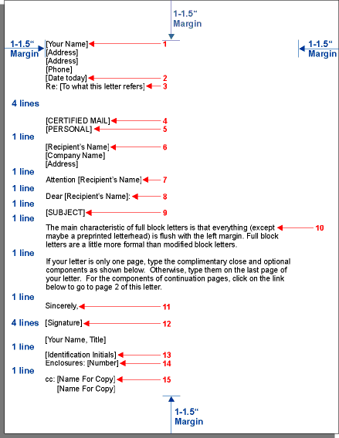

Sample Letter

Your Address
Your City, State, ZIP
(Your e-mail address if sending via e-mail)
Date
Name of Contact Person (if available)
Title (if available)
Company Name
Consumer Complaint Division (if you have no specific contact)
Street Address
City, State, Zip Code
Dear (Contact Person):
Re: (account number, if applicable)
On (date), I (bought, leased, rented, or had repaired) a (name of the product, with serial or model number or service performed) at (location, date and other important details of the transaction).
Unfortunately, your product (or service) has not performed well (or the service was inadequate) because (state the problem). I am disappointed because (explain the problem: for example, the product does not work properly, the service was not performed correctly, I was billed the wrong amount, something was not disclosed clearly or was misrepresented, etc.).
To resolve the problem, I would appreciate your (state the specific action you want - money back, charge card credit, repair, exchange, etc.). Enclosed are copies (do not send originals) of my records (include receipts, guarantees, warranties, canceled checks, contracts, model and serial numbers, and any other documents).
I look forward to your reply and a resolution to my problem and will wait until (set a time limit) before seeking help from a consumer protection agency or the Better Business Bureau. Please contact me at the above address or by phone at (home and/or office numbers with area code).
Sincerely,
Your name
Enclosure(s)

Remember to:
- describe purchase
- include the name of product, serial number
- include the date and place of purchase
- state problem
- give history
- ask for specific action
- allow time for action
- state how you can be reached
- enclose copies of documents (but never send originals)
- Keep copies of all your letters, faxes, e-mails, and related documents

