Opportunity Recognition/Innovative Concept:
The soft drink industry is a global occurrence. The United States ranks first among countries in soft drink consumption and thus there has been a steady growth in this industry for years. People have created extraordinary high brand recognition with their purchases and dedication to their soft drinks.
Coke, Pepsi, and Cadbury Schweppes control over 91% of the US market share. With this in mind our group saw an opportunity to help Coca Cola increase its market share and place in the ginger ale field. We decided to create a line of ginger ale based drinks that will increase sales while offering a refreshing, innovative, and exciting new taste. Our group is taking advantage of the lack of marketing and availability of Seagram’s ginger ale, and we are offering an innovative way to help build it. We would like to introduce our line of innovate soft drinks called GinTropic™. The ideal flavor choices behind the GinTropic™ line open up a new door never before experimented within the ginger ale market. There have been instances of ginger ale grape and raspberry mixtures but none that include a line of 100% tropical fruit juices. This is where GinTropic™ comes into play. Our whole line is based on fruits commonly found on tropical islands that offer a wonderful refreshing taste especially when mixed with Seagram’s ginger ale. The colorful logo design should definitely raise eyebrows when attracting consumers, which will only lead to them trying our delicious product. GinTropic™ will give Coca Cola a chance to seize the opportunity that Seagram’s alone could not quite catch.

Benefits of GinTropic™:
- Refreshing original clean taste
- A blend of what you know giving you a new and refreshing taste
- No caffeine
- Made with 100% real fruit juices
- Provides vitamins and minerals
- Nutrient dense (helps prevent disease)

Logo Designs:
The following are design concepts created by our design staff. The final designs will be worked out. We just wanted to show the different artwork concepts.

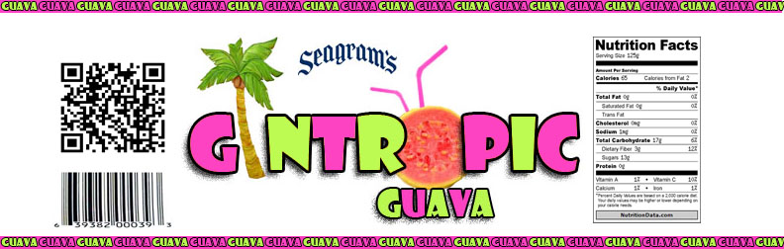
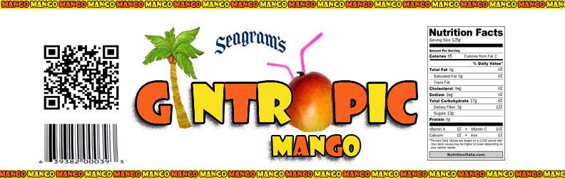

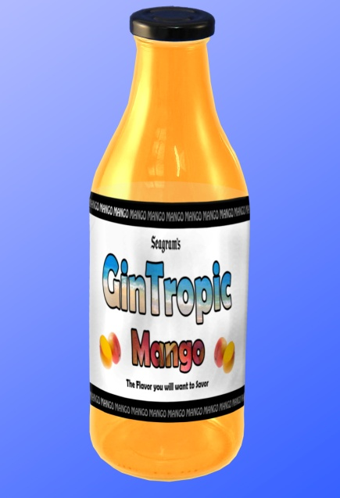
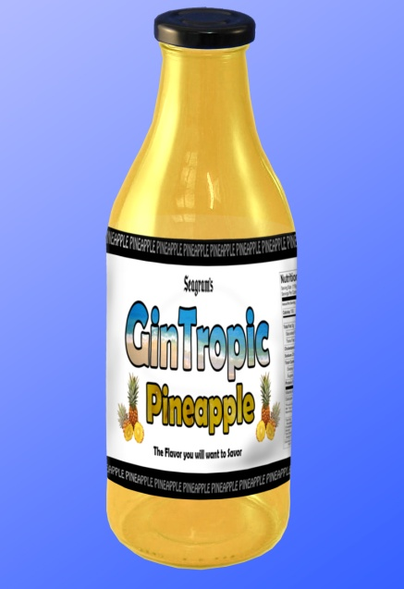
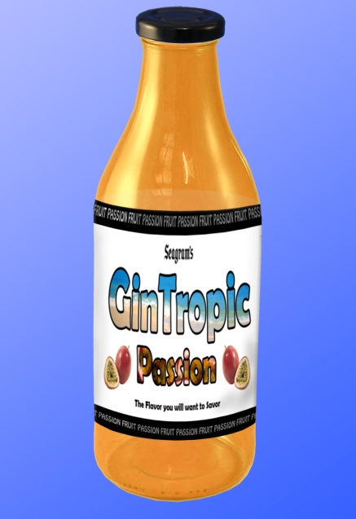
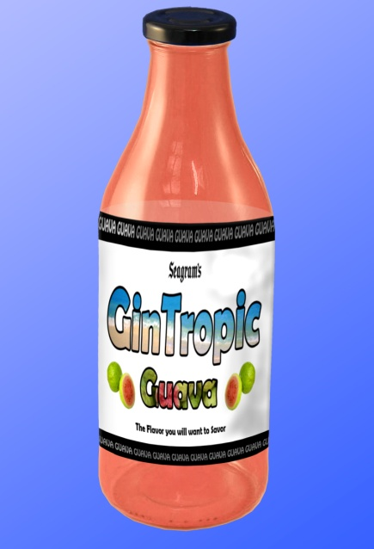

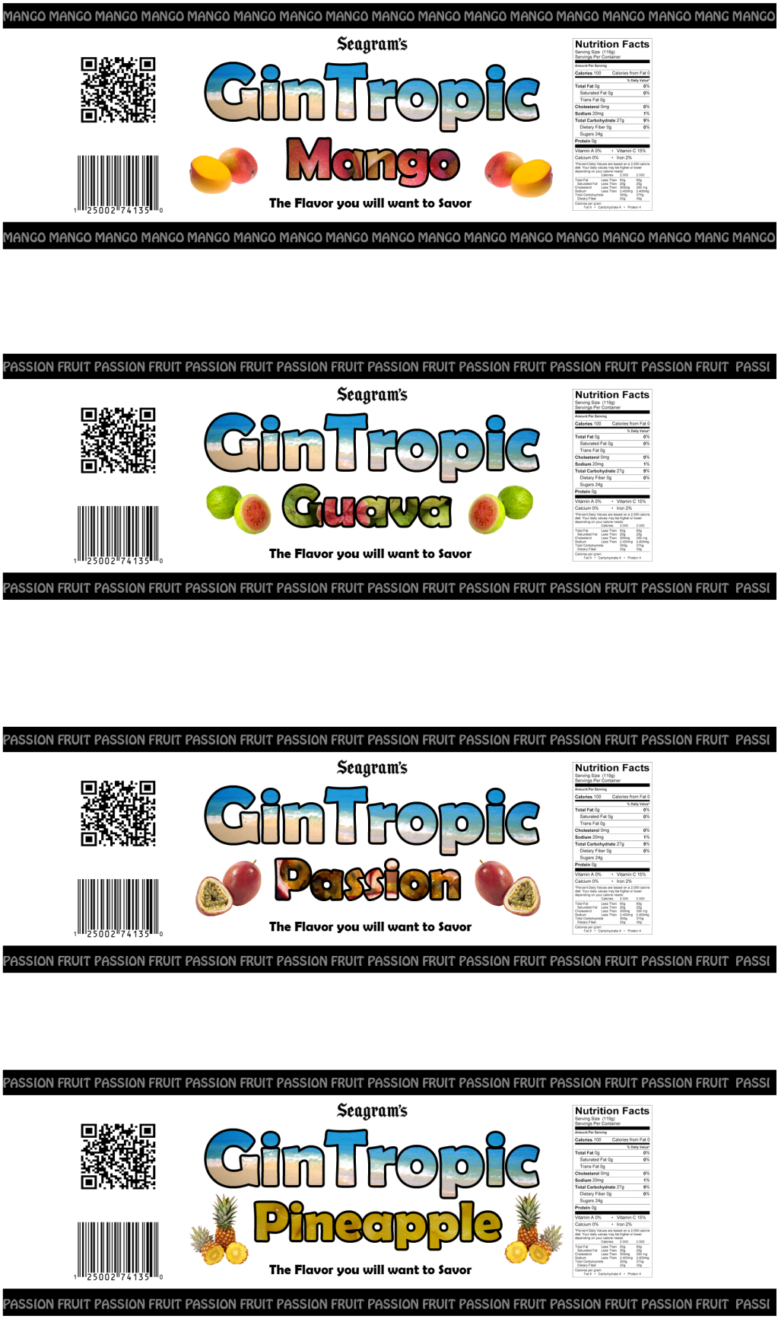

Defend Your Innovation:
When we started asking the public to name the different brands of ginger ale only two names came up in every conversation; Canada Dry and Schweppes. We then went to the local supermarkets and noticed that Canada Dry and Schweppes both had a large share of the self space while Seagram’s had very little space. It was these findings plus the fact that Coca Cola itself instituted a mandate to promote their ginger ale and thus the idea was born to create a fresh new line of tropical ginger ale drinks. These drinks will add to the “comfortable, sophistication that Seagram’s ginger ale can bring and enhance their campaign which highlights the clean and natural ginger flavor.” The mixture of 100% natural tropic fruit juices combined with the clean natural ginger flavor leading to the creation of an innovative and exciting taste.
Being able to promote a drink that provides vitamins and minerals, has fewer calories than most soft drinks, is nutrient dense, and can help the bodies digestive system is an advantage that we will benefit from. Even with all these behind the scene benefits most consumes will just flat out love the taste.
Our taste test yielded the following results. Out of the 150 actual testers 66% enjoyed the line of GinTropic™ flavors. Guava was the clear favorite with 74% overall satisfaction rating and a clear pick for the overall best taste. These findings make it clear to us that the GinTropic™ line of soft drinks can and will increase Coca Cola’s brand recognition of Seagram’s ginger ale and thus a greater share of the overall ginger ale market.
With an average of 5 million sodas being drunk every hour we feel the GinTropic™ line of ginger ale drinks with its blend of what you know giving a new tropical refreshing taste brings out “The flavor you’ll love to savor” and put Seagram’s ginger ale on the map.
Marketing Pitch:
Scenario: Say you are at a friend’s house relaxing and enjoying each other’s company, when they offer you a refreshing ginger ale. You gladly accept, but what brand is it? Is it Seagram’s? Chances are it probably isn’t. Solution, GinTropic™ offers a new brand of ginger ale with an original taste that can be added to the Coca Cola Seagram’s line. GinTropic™ will allow Coca Cola to increase the availability of Seagram’s ginger ale in retail outlets across the U.S. with its incredible “Flavor that you’ll want to savor”. GinTropic™ is low in calories, contains no caffeine, and is composed of real fruit juice with a variety of island themed flavors that include mango, pineapple, guava, and passion fruit. GinTropic™ can put Seagram’s on the map in a ginger ale and mixers category that is large and growing in the U.S. With the help of GinTropic™, Seagram’s name will be a household favorite within easy reach of people everywhere.
Customers:
Demographics: Population/Income
We are targeting men and women who like a “good for you” soft drink. Our target audience is people in their mid teens to 50 (the average annual number of drinks consumed in this age group was the highest at 200), people who prefer natural flavors, and people who have discretionary funds and want a reasonably priced soft drink.
Geographic’s: Location
The line of GinTropic™ soft drinks will be available for consumption by anyone in the United States. The largest growth for the product line will take place in urban cities where the consumers already have a preference for soft drinks. We also know that the larger cities have the highest Hispanic population and this population likes all types of juices, we are counting on them to enjoy the tropical ginger taste of GinTropic™.
Psychographics:
The types of people who would be attracted to our soft drinks are people who are concerned about their overall health; people who like fruit juices, people who want to get away from the everyday taste of sodas and experience the “tropical” taste of GinTropic™.
Buying Patterns:
Behavior of our customers includes people who purchase a soft drink at least once a week. Consumers that are on the go, we call them “Grab and Go” consumers.
Media:
We actually decided to do a video diary of the project. We hope you enjoy it.
Video Diary - http://www.youtube.com/watch?v=AkJ6gCN4hX4
Here is a link to our commercial which also can be found in our video diary.
Commercial - http://www.youtube.com/watch?v=ruScAkn-ag4

Team Players:
Akeem Allen, Trumell Arnumn, Ray Bartee, Chevelle Cooke, Phillip Guthrie, Dasha Hill, Jasseem Howard, Zabdiel, Jimenez, Corey Mackey, Piul Makai, Matthew Montminy, Alexa Morales, Pitor Musial, Desiree Nicholas, Ivanisha Pedrogo, Nelson Reis, Leidy Rivera, Hector Serrano, Taha Shabazz, Paul Stamper, Jaleel Thompson, Shataya Thompson

