Describe the Opportunity
High school students across the country dread the day that they have to take the notorious SAT exam. We are constantly reminded to study so that we are properly prepared, but studying is boring, which makes us stray away from doing so. Therefore we don’t acquire the needed practice to get through the SAT exam with the grade we want.
In our state of Connecticut, there is evidence that inner-city schools such as the ones in Hartford, the average SAT score is much lower than those of students in suburban areas. As a part of this inner-city group, we find this to be unacceptable and have a plan to make a difference by helping students improve their performance. Researchers have found that games can have a positive effect on the brain; it improves a person’s problem solving, logics, and perception, which are skills required to perform well on the SAT’s. This is where Learn-Pop will make a difference!
The Product
Learn-Pop is a game that is both educational and fun! This game will be a new, fun, and competitive way of prepping yourself for the SAT. This game features two different subjects as well as leaderboards to compare you to other schools who are also participating in the game. Also, as a token of our appreciation we are offering free SAT waivers to the school with the overall highest score.
When you first launch the Learn-Pop game, you will have multiple categories to choose from, such as math and reading. Once you have chosen what you want to practice the action begins. Bubbles begin to appear on your screen, each with different answers but only one has the correct answer. Choose wisely because only the ones you get right add points to your score and remember every school is competing for the most points which will earn their school free SAT waivers. Also, don’t forget to be quick because you are being timed just like you would be during the actual SAT.

Defend our Innovation
This game provides a fun learning activity for high school students, meant to assist them in studying for the SATs. It presents a game in which the player must choose the correct bubble, corresponding to the question, in order to win. It has multiple settings that can be changed to fit the player, such as changing the pace of the game, what kind of questions to be used, and difficulty. It is also written using language that a high school freshman would understand clearly, so as not to discourage younger students from beginning their SAT studies early. In addition to this, competition between students in schools is heavily encouraged, and we hope to give students who go above and beyond in their studies and score higher than others in Learn-Pop free fee waivers for the real tests. With this, students will be able to benefit from this game by not only having fun while learning, but also earning fee waivers for the SATs.

Marketing Pitch
Would it be nice to be rewarded a beneficial prize after playing a game and improve your SAT scores at the same time? Of course, you do and that is where Learn Pop, pops in! Learn Pop, not only help you improve your SAT score but also give you the chance to compete for free fee waivers for your school. Learn Pop also lets you keep. track of what place your school is in on the leadership board. As you use the game, you are able to see your scores for each SAT section and what answer you got wrong and what area you need to improve in, perfect way to make learning competitively fun.

The Customers
Location:
This game will be available to any students in the United States. Students will be able to test their SAT ability, and know what sections they need to improve in. Also at the same time be in a competition with other schools to win free fee waivers for their school.

Population:
There are approximately 1,270,370 public and private secondary schools in the U.S. Studies have shown that about 60% of them currently have smart phones, making them a potential market. High school aged students who want to go to college and care about their grades. Kids who live in inner-city areas needing extra help for the test.

Personality:
This game is specifically for high school students who are looking for a good way to study for their SAT’s and possibility to win free fee waivers in the process.
Behavior:
This game will appeal mostly to students who play mobile games and that have a smart phone or tablet, and want to study and increase their SAT score, with a possibility of a fee waivers for their schools SAT’s.
Income:
Any smartphone or tablet owners of all income levels will be able to get this game for free, and also to any school that has paid the $5 dollar per student contest to enter the competition for fee waivers.

Team Members: Justice Hightower, Jeremiah Nembhard, Nicholas Medina, Zhane Camby, Matt Callahan, and Brittaney Campbell

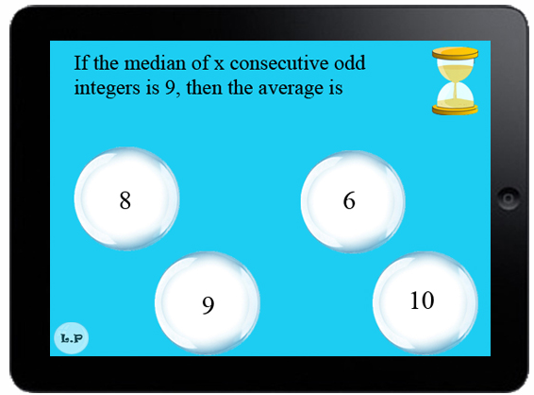
Game Design/Logo

