AIPB Research, A subsidiary of Griffey-Commerce
Market Research: Eva’s Edibles
A comprehensive examination of feasibility

Akeem Allen, Project Manager Brandon Bragg, Statistical Researcher Ivanisha Negron, Researcher Piul Makai, Data Coordinator
February 7th, 2013

Table of Contents

Abstract…………………………………………………………….. I
Introduction………………………………………………………... II
Background………………………………………………………...III
Results……………………………………………………………..IV
Citations………………………………………………………….....V

Abstract: Eva’s Edibles
Eva’s Edibles is a proposed personal chef service by Eva Tan, a graduate of Columbus State Community College who majored in Business Management. Eva hired our team to conduct market research for her business idea, and to assess its feasibility. The comprehensive research and study from our team is comprised of both primary and secondary sources, which includes, but is not limited to conducting surveys of the target market, obtaining data from sources such as the US Census and Bureau of Labor Statistics, and researching the target market extensively; who they are in terms of age and sex, what their economic status is, and what their geographic surroundings were. This study also encompasses the educated opinions of our team, which were made by way ample discussion, and with the important prioritization of feasibility in mind.
Introduction
The purpose of this project is to determine the target and potential markets of Eva’s Edibles, and to assess the feasibility of the company if she chooses to start it in the Columbus Ohio area. During research, we expected to learn how to find industry data effectively, how to think rationally, and apply the use of primary sourcing to determine things that cannot be expressed explicitly through secondary market research. We used these methods of research, as well as others to determine whether Eva should begin her company full-time.

Background
The information needed in order to begin conducting research was provided by Eva; she was a graduate of Columbus State Community College who majored in Business Management, and is currently employed with Ohio State University, as an event planner. Eva had always been looking out for business opportunities, but never found any, so she settled for employment. But as an administrative assistant, she discovered her true passion through her event-planning duties; cooking. This prompted her to hire our company, to conduct research for her personal chef startup idea. Eva’s business will serve the Columbus Ohio area, and her clientele will typically consist of people with discretionary funds and little free time. This was Eva’s desired target market, and was requested by her that we gather information from these people in particular. Beyond Eva’s request, our company needed to gather information about the overall demographics of Columbus Ohio, the specialty food service industry, and gather secondary information from the US Census, as well as primary data we gathered through surveying target customers at the local mall.
Team Results
By working full-time, Eva gave up on her search for an opportunity to start her own business, and along with that, she lost the time she could have invested into researching her market and finding possible ideas for a business. Collectively, our company would have advised Eva to possibly find a part-time job to pay her bills and student loans, and work on developing her new business idea in her downtime.

From the information gathered, we believe that Eva would like to know the following:
- Who her target market is
- Her industry, and its size
- The feasibility of her company’s profitability in the Columbus, OH area
- Who her competition is
- What she can use as her niche
Data Table
Question | Primary/Secondary Data | How can Eva find this information?
What Industry is a personal Chef in? | Secondary | Online (Bls.gov/technomic.com)
What type of training and certification does she need? | Primary/Secondary | Ask a chef/Online (Google Search)
What legal issues will she need to consider? | Primary/Secondary | Ask a lawyer/ Online (legalzoom.com)
Who is her target Market? | Primary/Secondary | Online/Personal Preference (Google Search)
How big is her Market? | Secondary | Online (technomic.com, bizstats.com)
How can she find out more about the growth rate of Columbus? | Secondary | Online (census.gov, city-data.org)
Who are her main competitors? | Primary/Secondary | Call personal chef in the area/online (Google Search)
What are her potential customers looking for? | Primary | Interview potential market directly

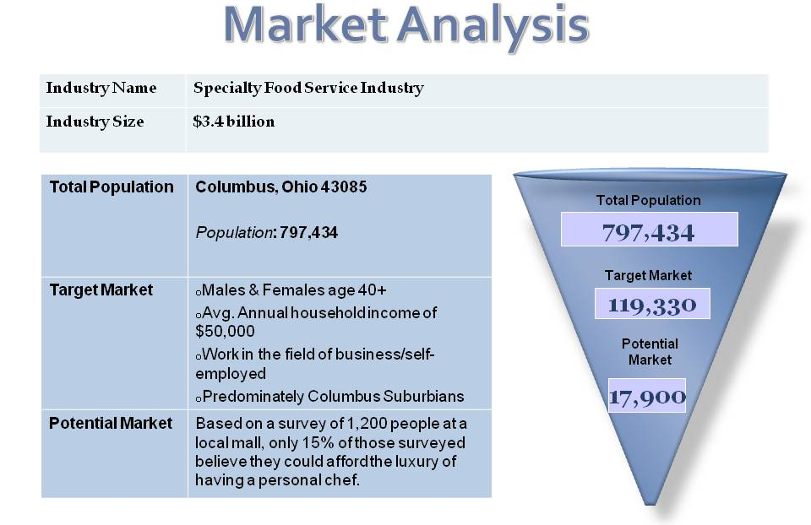

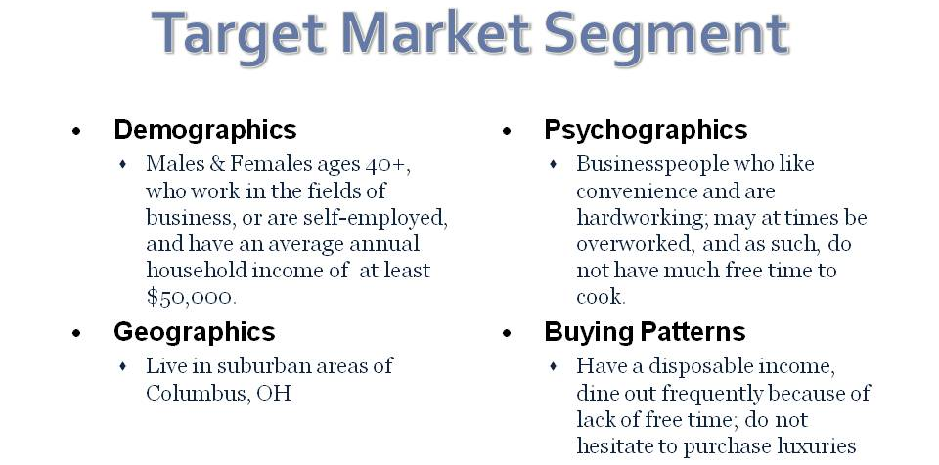

SUMMARY
Eva’s Edibles is a proposed personal chef service. Her start-up expenditures will include the following: the obtaining of her permits, licenses and certifications, obtaining insurance and basic equipment to cook for her clients; which totals to about $300. The permits and licenses mentioned before vary by state, and though they are not legally required to run her service, she should obtain them, in the event that she encounters any legal trouble. As for training, she needs none, but in order to successfully obtain clients, she should undergo some form of formal training. In the Columbus area, her main competitors are the “Columbus Personal Chef” company, and “Jaclyn’s Personal Chef Services”, who are well-established personal chef services in her area. The growth potential for Eva’s business is generally positive; according to Enterpreneur Magazine, the personal chef industry is “one of the 12 fastest-growing businesses in the country, and that within the next five years, at the present rate of growth, there will be nearly 25,000 operating personal chefs in the United States serving nearly 300,000 clients.

REFERENCES
www.personalchefmedia.com
www.city-data.com
www.census.gov
www.bls.gov
www.columbuspersonalchef.com
www.jaclyndecourcey.personalchef.com
www.uspca.com
www.google.com/publicdata
www.technomic.com

