Business Plan

E-commerce Business Design:
Happy Hour Cabby

“We Drive to Save Lives”

Pathways to Technology
184 Windsor Ave.
Windsor, Ct. 06095
Telephone (860)695-9450

Table of Contents

i. Table of Contents 2

ii. Executive Summary 3

iii. General Company Description 4

iv. Services 9

v. Marketing Analysis 11

vi. Financial Plan 15

vii. Appendix 19

Executive Summary
Every day, almost 30 people in the United States die in motor vehicle crashes that involve an alcohol-impaired driver. This amounts to one death every 48 minutes. The annual cost of alcohol –related crashes totals more than $51 billion… Thankfully there are effective measures that can help prevent injuries and deaths from alcohol- impaired driving and Happy Hour Cabby™ is one of them.
Happy Hour Cabby™ a Greater Hartford CT based company, whose mission is to provide reliable, timely, and safe transportation services to our community. Our goal is to decrease the percentage of DUI arrests in our community and thus saving lives. The company will establish its presence in the industry by its new and innovative way of helping with the on- going problem of drinking and driving. Happy Hour Cabby™ has been born through the effort of young adults who have chosen to make a difference in their life time.
Happy Hour Cabby™ a non-profit organization will provide transportation services during specific hours of the week using the latest equipment and technology to facilitate the travel of individuals in and around the Greater Hartford Area. The company’s services show that we are an innovative, forward thinking company that recognizes the need to adapt with ever-changing customer needs, new more stringent DUI laws, a need for an environmental conscious society, and the new technology advances that will lead us into the future. At Happy Hour Cabby™ our philosophy is one that emphasizes adaptability, service to others, and a realization that effective communication and a pro-active approach is important to the solution of this problem. The company also realizes, in an environment where there are more cars on the road than ever, the importance of this service has never been greater.
Happy Hour Cabby™ is seeking support and sponsorship from federal and state government, local companies, restaurants, hotels, and entertainment establishments that are interested in the same pro-active approach to helping with our effort to educate and motivate people to act in a responsible manner when it comes to their drinking and driving. We have chosen our target audience to be people who frequent local establishments and want to do the right thing.

General Company Description
Business idea:
Our business idea is to create a non-profit organization working with local businesses to set up a safe, reliable, and timely transportation service for the Greater Hartford Area. We will provide a three season in city local pedicab service and also provide a full transportation service specifically designed for the weekend crowds at a price that cannot be beat. We are taking a pro-active approach to the problem of driving and drinking and thus helping to save lives.
Our official business name:
Happy Hour Cabby™ founded in 2012 in Hartford Connecticut, by the students at Pathways to Technology.
Legal Structure:
Happy Hour Cabby™ is a Connecticut nonprofit corporation
Mission Statement:
Our mission is to provide reliable, timely, and safe transportation services to our community. We exist to attract and maintain customers while taking a proactive approach to their safety. We are also committed to our environment and will in-turn provide services that promote sustainability. We will be committed to reducing our consumption and waste, reusing what we can, and recycling where we can.
Contact information:
Happy Hour Cabby™
184 Windsor Ave.
Windsor, Connecticut 06095
(860) 233 -7233
Company Strategy:
At Happy Hour Cabby™ our philosophy is one that emphasizes adaptability, service to others, and a realization that effective communication and a pro-active approach to the cities problem of safe transportation during those “happy hour” times is important and needed. The company’s strategy is to build a reputation as a respected and responsible alternative to everyday transportation needs. We will continuously monitor the laws, work on our technology needs, and build on our sustainability foundation.
Objectives:
- Educate and motivate people to do the right thing
- Support for MADD and SADD
- Build a cliental base that will buy a yearly membership
- Pursue an aggressive marketing campaign to create public awareness
- Galvanize the community for support
- Deliver a safe and reliable transportation service
Highlights of Happy Hour Cabby:
- Pedicabs will provide green, people-powered transportation to residents and visitors within Hartford shopping and entertainment district
- Relationships with MADD and SADD
- Debit and credit card system for convenient payment processing
- Radio Frequency Identification for ease of identification. Members will be issued a RFID card which kept on their person will be activated when they enter the vehicle.
- IPads and smart phones for all vehicles for GPS and communication purposes
- Strategic relationships have been reached with restaurants, hotels, and entertainment establishments
- Reasonable flat rates for cab service and simple priced pedicab service within city
- Use of hybrid vehicles to maintain the green theme

Company Organizational Chart
As a non-profit organization we will have a board of directors that will oversee and enforce the rules, regulations and policies of the organization. The business will have officers (Chief Executive Officer and four Department Heads) who will be selected by the board of directors. These officers will manage the staff and the daily operation of the business. The staff will consist of paid and volunteer workers who are given their duties by the officers of the nonprofit organization. Our board will be made up of local executives from the following areas: Hotel, Restaurant, Legal, Insurance, Entertainment, and Education.
CEO Happy Hour Cabby
Community Outreach
Budget & Finance
Transportation
Advertising & Marketing
Board of Directors

Current Conditions
The state Department of Transportation regulates Connecticut's 90 taxi companies, and has assigned 11 of those companies to Greater Hartford as their primary territory. Those 11 companies have 114 total registered cabs, said Dennis J. King, manager of the regulatory and compliance unit of the DOT's bureau of public transportation, which regulates taxis. For the most part short fare rides are the most undesired and a few years ago, the state DOT received a rash of complaints from people after taxi drivers in downtown Hartford refused to take them on short rides. Happy Hour Cabby™ will fill that need with its pedicab service as well as local cab service. The idea to service our community is what we have in mind.

SWOT
The following SWOT analysis captures the key strength and weakness within our business as well as the opportunities and threats that present themselves from outside the business.
STRENGTHS:
- Committed to our environment
- Reasonable prices will allow us to be a leader in the transportation area
- We are a locally run business with partnerships with state government, restaurants, hotels, entertainment establishments, and local businesses giving us a large base in which to promote.
- Creative use of technology
- Our hours of operation are limited which will keep us focused on our immediate goals.
WEAKNESS:
- General apathy for the business
- Lack of formal business knowledge and inexperience.
- Need for a special waiver from the state to run the business
OPPORTUNITIES:
- Regular cabs do not like to service “short” distance fares
- Change in DUI laws bringing about more stringent consequences
- Restaurants need new and innovative ways to advertise and generate business
- No pedicabs in city to date
- Partner with MADD & SADD
- High cost of gas might fuel people’s interest in our business because of our reasonable cost

THREATS:
- Competition from many worthwhile causes for people’s discretionary funds.
- Could be dangerous when dealing with public especially when alcohol is involved
- Competition from established cab companies
- Cost of operating and maintenance of vehicles can be expensive
- People might not want or trust our service

Services
Niche/Services
Building Happy Hour Cabby™ it became clear that our niche would be our purpose, our affordability and our opportune time of operation. We hope to foster a sense of urgency so that people felt compelled to take a stand and use our services to protect themselves and others.
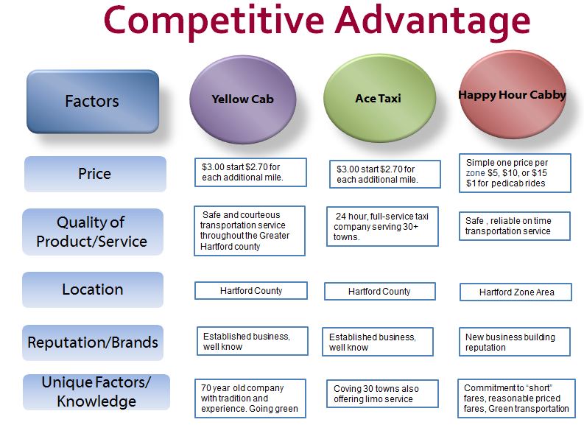
We will be providing two types of services to our customers. First, we will provide pedicab services in the city of Hartford from 3:00 pm – 2:00 am on Thursdays, Friday and Saturdays. Second, we will provide actual cab services to three different zones (distance reference points) during the same hours. If anyone needs a ride outside our reference point they will have to use one of our competitors. Our cost structure and zone description can be found below.

Competitive Advantage
The advantages that our company has over our competitors is that we are more affordable, there is ease of availability to our transportation, conviction to the environment, a simple payment method, our use of technology to accelerate all aspects of the customers experience, and our commitment dedication to our community.

Pricing
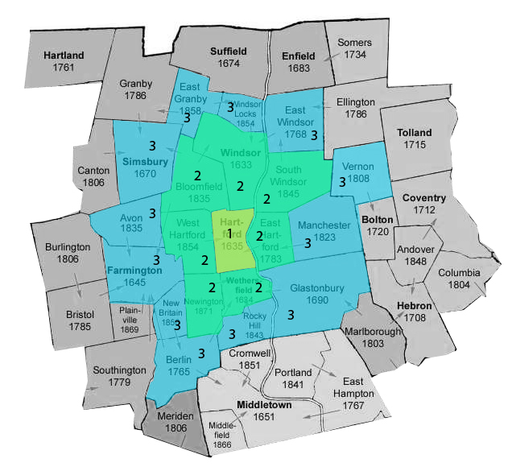
As a non-profit business our goals are to provide a reliable and affordable alternative transportation for the weekend people who like to enjoy the city activities. Step one will be to get the word out about the yearly membership offer. Customers will purchase a yearly membership for a $50.00 fee plus a onetime charge of $5.00 for the RFID (radio frequency identification card) card that will be used for ride access and payment. Those that purchase the membership will receive the following: free pedicab rides, 40% off zone 1 cab fares, 30% off zone 2 cab fares, 20% off zone 3, discounts at partner restaurants and hotels, and next day free ride back to vehicle if left in the city. Our pricing structure for cab service is centered on a simple price based on which zone you are being picked up or dropped off from. The prices for the zones are as followed: zone 1 $5.00, zone 2 $10.00 and zone 3 $15.00. An addition two dollar per person charge will be added for additional riders. Our pedicab service will have a flat rate of $1.00 per ride. We will have special coupons for patrons of our sponsoring restaurants and hotels.

Marketing Analysis
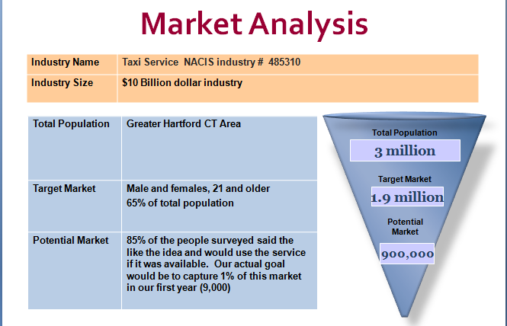
Industry:
Our industry is a 10 billion dollar industry. There are approximately 171,000 vehicles licensed as taxicabs in the United States. Most of those taxicabs are operated through 6,300 taxicab organizations. These taxicab organizations differ in many ways; how they are organized (privately held companies, driver owned, cooperatives, etc.), their ability to provide comprehensive, community-wide taxicab service, and the number of taxicabs they operate. Although we are a bit of a hybrid to this type of service we feel there is a definite need for our innovative transportation service.
Market Research:
Our first step in this process was to define our target market and the best way to define our market is to conduct a survey. We wanted to find out where people lived, why they came to the city, how often they ate out, are they business travelers, and how many times they drank and drove etc. With the data we wanted to create a marketing message that would give us a unique selling position that would answer the question of why would potential customers chooses our transportation services.

Our research shows that our key to success would be that we are able to meet these market needs:
- Reliability
- Convenience
- Professionalism
- Cost effectiveness
- Ability to reach our customers on an emotional level
- Safety value
As you can see from the chart above that an overwhelming number of people surveyed thought that our business idea is practical and needed. We are projecting capturing 1% our target market or 9,000 people who will buy a yearly membership.
Our next task was to reach out to local business to see their reaction to the business idea and could we foster a business partnership with these businesses. We have contacted many of the following types of businesses:
- Restaurants
- Hotels
- Banquet facilities
- Entertainment facilities
- Local businesses (Aetna, The Hartford, Travelers, United Technologies)
- Local, state and federal government
To date we have 30 businesses that are onboard with this idea as you will notice in the appendix.

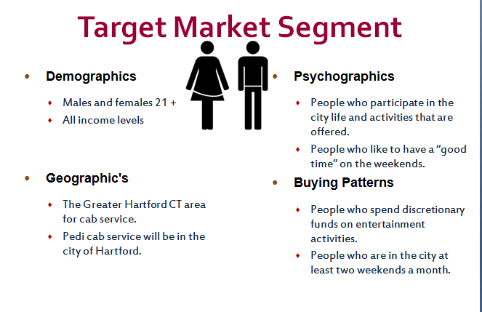
Customers/Target Market:
Happy Hour Cabby’s target audience will have the following characteristics:
- People who want to do the right thing
- People who care about the environment
- People who like technology
- People who like to eat out
Our focus will be on males and females age twenty-one and older in any income level who are motivated to use our service because of its ease, cost effectiveness, safety, and overall quality that will be associated with our services. This audience will be from the Greater Hartford Area, people who like to participate in the city activities, and whose buying patterns include weekend visits to the cities entertainment and shopping district.
Marketing Mix:
Happy Hour Cabby™ marketing mix is comprised of the following:
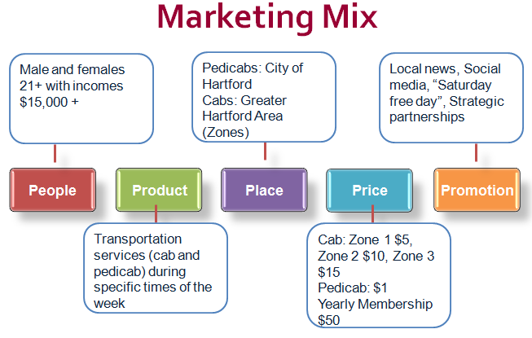

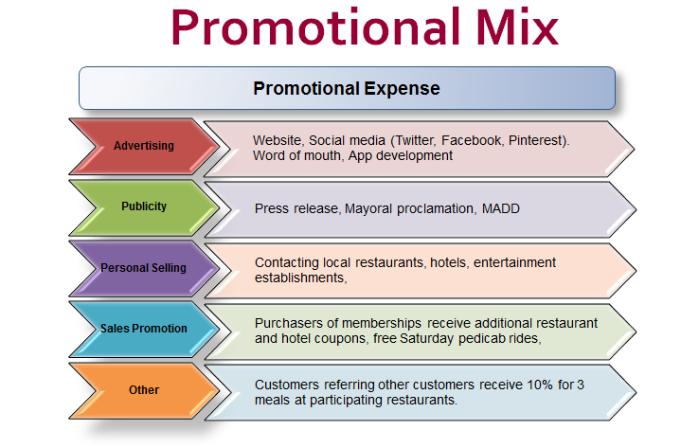
Promotional Mix:
We will advertise and promote our product through our E-commerce website, app development, social media, local newspapers, local churches, flyers, brochures, business cards, direct marketing (Valpak), and email.
Methods | Description
E-commerce  Social Media: Facebook, Twitter, LinkedIn, Pinterest, App development | Our website will allow customers to browse, navigate, and purchase our services.  There is high selectivity, low cost, and interactive capabilities
Local Newspapers | We will create ads to supply customers with hours of operation and contact information along with any promotion coupons.  Usually good local coverage with broad acceptability.
Personal selling | Contacting all businesses that might have the same pro-active approach as Happy Hour Cabby™. Doing charity events and “free” ride days
Flyers | We will pass out flyers to raise awareness of our service.
Brochures, business cards | Our brochures will include partners, coupons, and hours of operation.
E-mail, Constant Contact | We will create a mailing list so that we can stay in touch with our customers to inform them about special events, sales, and promotions.
Valpak direct marketing | More than 53 million households receive these Valpak coupons in their mailbox.  No ad competition within the same medium and allows personalization.

Financial Plan
Start-Up Summary:
Happy Hour Cabby™ understands that a special waiver has to be rendered from the Department of Transportaion who oversees the cab industry in the State of Connecticuit. We also understand that we have to meet all the DMV requirements including an F endorsement and the City of Hartford’s pedicab ordinance all which has to be reflected in our start-up costs.
Description | Cost
2 Honda Civic GX (natural gas)  1 12 Passenger Van  5 Pedicab (Main Street Pedicab, made in america)  Regitration of cars and pedicabs  License pedicab  Initial gas  Maintenance/Cleaning | ($28,000 each with signage and top piece) $56,000.00  ($32,000 each with signage and top piece) $32,000.00  ($3,500 each with signage) $17,500.00  ($80 each car, $94 van, $50 pedicab) $540.00  ($25 each) $125.00  (First two fill-ups) $250.00  (First two months) $300.00
Lawyer and Accountant | $1,300.00
Insurance (Business and vehicles | ($8,600 for year… first three months) $2148.00
Rent (for pedicab storage) | ( first three months) $600.00
Cash Reserve | (3 times monthly expense) $90,000.00
RFID Equipment  Computer/Ipads, phones  3 Square Debit Credit card readers  Domain name/website hosting  TOTAL START-UP COST | $3,500.00  $3,500.00  ($10 each) $30.00  $100.00  $207,893.00
Monthly Expenses:
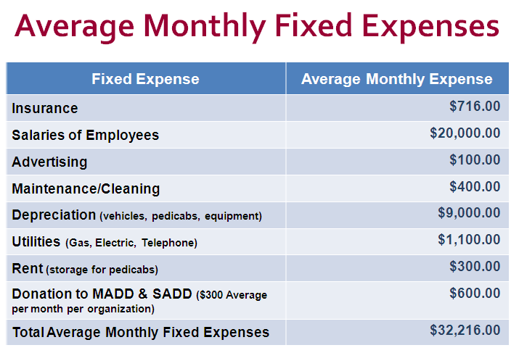
Happy Hour Cabby™ foresees the following monthly expenses. We are basing our expenses on a three day use of all vehicles (Thursday through Saturday) per week. Salaries are based on drivers and administrative personnel. We accounted for annual depreciation of vehicles and equipment over a period of time (ten years for the vehicles and five for the equipment). We will be supporting two organizations that are the driving force of our mission and goals.

Cash Flow:
Happy Hour Cabby™ will have different forms of income that will sustain the business operations. Income from a Department of Transportation Grant, transportation revenue, membership fees, and partnership advertising revenue will all be used to offset the cost of the business. This is the cash flow for a given month. This positive cash flow will be used to pay off our interest free loan of $300,000.00
Description | Amount Total
INCOME:
Membership Fees (500) | $25,000.00
Energy Grant | $ 836.00
Fares | $ 7,200.00
Partnership Advertising | $ 3,500.00
Cash Flow form income  EXPENSES:  Insurance  Salaries  Advetising  Maintenance/Cleaning  Depreciation  Utilities  Rent  Donations  Cash flow from expense  Cash Flow | $36,536.00  $ 716.00  $20,0000.00  $ 100.00  $ 400.00  $ 9,000.00  $ 1,100.00  $ 300.00  $ 600.00  $32,216.00  $ 4,320.00

Break Even Analysis:

It will take Happy Hour Cabby™ 75 payments or 6 years and three months to repay the loan.
Month Payment on loan Loan Amount Owed
1 $4,000 $296,000
2 $8,000 $292,000
3 $12,000 $288,000
4 $16,000 $284,000
5 $20,000 $280,000
6 $24,000 $276,000
7 $28,000 $272,000
71 $284,000 $16,000
72 $288,000 $12,000
73 $292,000 $8,000
74 $296,000 $4,000
75 $300,000 $0

Appendix

Benefits of Happy Hour Cabby™:
Fostering a business partnership between the city, local business and Happy Hour Cabby™ will cause a win-win situation for the whole community. Below are some of the benefits for those involved:
Benefits to Consumer:
- Save reliable transportation
- Ease of use
- Cost effective way to enjoy night
- No arrest, no record, no $$$$$$ spent to defend yourself
- Easy way to help environment
Benefits to City:
- Provides safe transportation
- Makes a green solution for transportation concerns
- Shows that they care about their community members
- Keeps city property intact
Benefits to Partners:
- More customers
- Additional revenue
- New and innovative way to advertise
- Shows they care about their community and environment

Penalty Charts:
DWI DUI Penalty Charts from the DMV and the Courts:

CT DUI Law DMV Administrative Penalty Chart
Blood Alcohol Level | First Offense | Second Offense | Third Offense
Refusal to submit to a blood, breath or urine test | 6 months | 1 year | 3 years
Test results of .02 or higher and you are under twenty-one years of age | 90 days | 9 months | 2 years
Test results of .08 or higher; up to, but not including, .16 | 90 days | 9 months | 2 years
Test results of .16 or higher | 120 days | 10 months | 2 1/2 years

CT DUI Law Courthouse/Criminal Penalties
First Offense*  Test results of .08 or higher | Second Offense*  (within 10 years) Test results of .08 or higher | Third Offense*  (within 10 years of last conviction) Test results of .08 or higher
Fine: $500 to $1,000 | $1,000 to $4,000 | $2,000 to $8,000
Jail: 6 mo. 48 hrs. minimum mandatory or 6 mo., suspended with 100 hrs. community service. | 2 yrs., 120 days minimum mandatory and 100 hrs. of community service | 3 yrs., 1 yr. minimum mandatory and 100 hrs. of community service
Suspension: One year | Three years (or until you are 21 years of age, whichever is longer) | Permanent Revocation

Design and Branding:
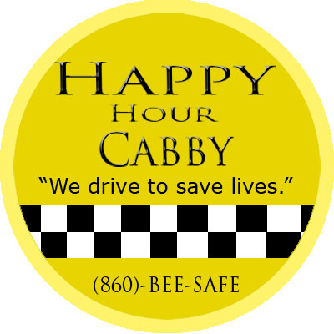
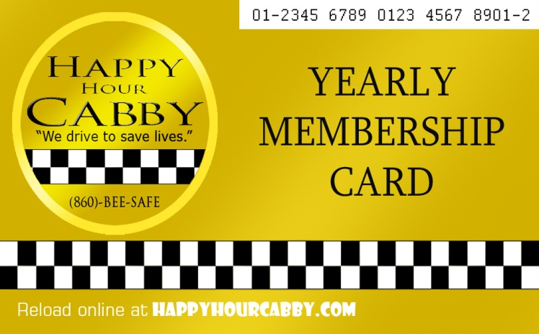

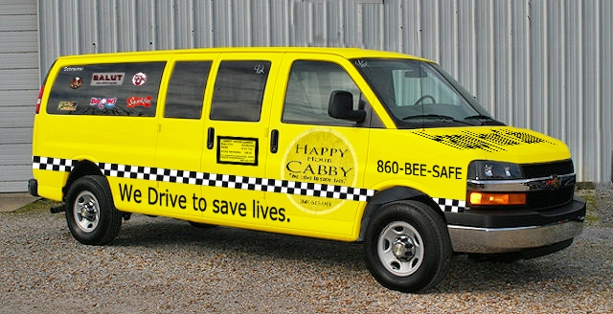

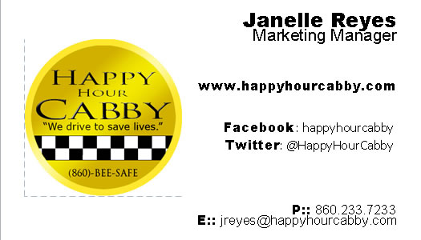

Partnered Business:
Resturants/Bars
Agave Grill Arch Street Tavern Black Bear Saloon
Black-eyed Sally's City Steam Brewery Cafe Coach's Sports Tavern
Firebox Restaurant First and Last Max Downtown
Morton's the Steakhouse Salutes Tavern Downtown
Trumbull Kitchen Vaughan's Public House Vito's by the Park
Wood N Tap

Clubs
Club Blu The Half Door McKinnon's Irish Pub
Pig's Eye Pub Red Rock Tavern Sully's Pub
The Russian Lady The Webster Thearter

Hotels
Holiday Inn Express Ramada Inn Hilton
Fairfield Inn Hartford Marriot Residence Inn Downtown
Days Inn

