Eva’s Edibles Market Research

Jhomar Fernandez
Stephon Sears
Scott Blanchard
Jack Grahn

Ecommerce
Pathways to Technology
February 14, 2013

Table of contents
- Table of Contents…………………………………………………………………………………….2
- Abstract…....………………………………………………………………………………….……….3
- Introduction……………………………………………………………………………………………3
- Background……………………………………………………………………………………………3
- Team Results………………………………………………………………………………………….4
- Citation…………………………………………………………………………………………………6

Abstract:
The objective of this project was to try and create market research analysis for Eva’s Edible business idea in order to help her decide if this was a good business idea or not. During our research we also managed to help her decide on critical things like figuring out who she might sell her service to, and much more. We were able to research a lot of the necessary information that Eva needed and decided narrowed down her target market to families that make over $100,000 a year, and informed her that her potential market could be around 7,978 people. From our research we also found that she had five other competitors. After some thought and consideration we decided to tell Eva that her business idea was a good idea, since there are only 5 competitors but there are 7,978 potential customers, in which she will only need 15-30 loyal customers and have her hands very full.
Introduction:
The purpose of this activity is to learn how to conduct a market research analysis, so that we can do it for our own business when the time comes. Through this activity we will learn how to conduct a proper market research, become better writers, and learn how to analyze data. We are going to do an actual market research analysis for Eva, by researching a lot of data, analyzing the data, and telling her what we think of her business idea.
Background:
Eva’s Edible is a business that Eva is planning on creating in order to support herself, she came up with the idea when she heard her friend say that she would love for someone to come and cook for her once she got out of work so that she would not have to do it, and since Eva loves to cook she considered the idea. However, first she needed to figure out if this was a good idea, by researching the type of people that live in her area, are they wealthy? Do they work a lot of hours? So our team decided to take on the task of doing the research for Eva, and ultimately deciding for her if her business idea was a good idea. Through our research we decided to target families of higher income, $100,000 or more a year. So we went to the U.S census and got an estimate of how many people on Columbus Ohio make $100,000 or more a year. We also helped Eva figure out what her start-up expenditures might be, and what training or certification she needs. We also looked at the buying pattern of the people in Columbus Ohio, and if this people have enough time to cook, and spend their time doing other things, or if they have to sacrifice one for the other. In the end we decided that her business idea would be a good one, because she has a pretty big potential market for a personal chef, and if she can get even one-eighth of her potential market her hands would be full.

Team Results:
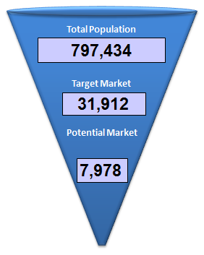
When Eva decided that she was going to work a full-time job in order to pay off her college loans, she threw away the idea of starting her own business. We as a team decided that we would have done the same thing that Eva did and give up the idea of starting her own business in order to pay off college loans, because it’s a risky move, and it’s not guaranteed that it will always succeed. If her business was to fail, she would have not been able to pay for her college loans and any other expenses that she might have.
If we were Eva and we were trying to create our own personal chef business we would have liked to know how many people can afford such a luxury of affording a personal chef through the market research. We would research the income of people living in the area of Columbus, Ohio to figure this out. From the market research, we would also like to figure out approximately how many people go out to eat every day, if the number is really low, than it would be obvious to us that people are already cooking at home and might not necessarily want a personal chef.
Question | Primary/Secondary Data | How can Eva find this information?
- What Industry is a personal chef in? | Both | She might be able to go around and ask personal chefs in her area to see if they know the industry they are in, or she can go online and search it in Google.
- What type of training and certification does she need? | Secondary Data | She might have to go on the website of a culinary university or college in order to figure out what type of certifications she needs in order to become a personal chef.
- What legal issues will she need to consider? | Secondary Data | She might be able to go to a library and read a book regarding this, she could search the web for this information, or she could pay for a lawyer to help her with this information.
- Who is her target market? | Primary Data | This is something she might need to figure out on her own, and think about what kind of people she is targeting.
- How big is her market? | Both | Once she decides who her target market is, she can than either surf the web for how many people fall into this category, or go and interview people and see how many of them fall in this category.
- How can she find out more about the growth rate of Columbus? | Secondary Data | She will probably need to go to the US Census, and look at how much Columbus Ohio is has been growing in the past couple of years, and estimate what it will be in the future.
- Who are her main competitors? | Secondary Data | She will need to look through magazines, newspapers, and websites and look for businesses that are providing the same service that she is planning on providing.
- What are her potential customers looking for? | Primary Data | To see what her potential customers are looking for she might need to go to the park, mall, or even downtown and interview random people and ask them what type of things they are looking for in a personal chef. (She could also advertise while doing this in order to make people more aware of personal chefs).
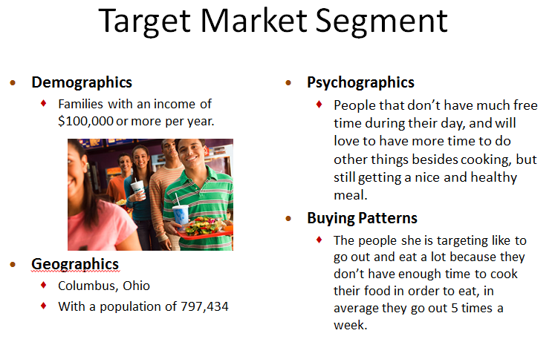
Before we started our market research analysis we had to figure out exactly what Eva was going to do, and we concluded, that as a personal chef she will, go to the house of the client she was contracted by where she will go shopping for the material she needs for the meal, and then cook it for them. The meals she cooks will most likely be determined the day before she goes to the client’s house by having a talk with the client so that she is able to satisfy their needs. When Eva starts her business she will spend a little less than $2,000 in cooking accessories and advertising her business so that people are aware of it.
However, in order for Eva to start her personal chef business she will need to get a personal chef business license, in which she needs to have a food and safety certificate to get. She can get the food and safety certificate by attending a short seminar in a local health department, and then she must pass the test they give her in order to get the food and safety certificate. From there she can go to the state’s auditor office or the state licensing office in order to get her personal chef business license. Through some more research we were able to recognize five other businesses in the area of Columbus which offer the same service as Eva meaning she won’t be alone and will have to fight for her costumers.

Citations:
http://www.census.gov/
http://factfinder2.census.gov/faces/tableservices/jsf/pages/productview.xhtml?src=bkmk
http://www.naics.com/
http://www.epipeline.com/mktng/nl-articles/naics-code-722310-2011.html
http://en.wikipedia.org/wiki/Personal_chef
http://www.hcareers.com/us/resourcecenter/tabid/306/articleid/636/default.aspx
http://www.hireachef.com/browse/US/Ohio/
http://www.entrepreneur.com/businessideas/674.html

