Product and Service
Explain your business idea. Be sure to describe the product or service and how it works in detail. (This explanation is important because it will demonstrate to the judges how a customer would use your product or service)
Fanbase 4 Kids is a series of web and mobile applications, each of which features a different professional sports team. The purpose of the application is to get children more engaged in following professional sports, and in turn encouraging them to participate in sports on their own. Each application has components that accomplish both of these goals. The corresponding service to this product is the production and continued management and maintenance of the product.
Product functions include:
- Monthly Photo Submission Contest – submit a picture of themselves for a given theme (holding a baseball bat, at the field, with the mascot, etc.); winners receive prizes
- Monthly Video Submission Contest – submit a short video of themselves playing the given sport in some way (getting a hit, making a catch, making a good throw, etc.); winners receive prizes
- Fun Facts about the team and its members (updated regularly)
- Earn Points by showing knowledge of the team (naming current players, recent game scores, upcoming games, etc.); once a point goal is reached, earn a prize
- Schedule of Kid’s Events(if applicable)
- Promotion for Team’s “Kid’s Club” (if applicable)

How does your idea address the issue defined in the innovation challenge category?
Fanbase 4 Kids addresses the issue presented by the SAP Technology Sports Challenge: Deepening Fan Engagement. The challenge is to “develop an app, game or technology initiative for the sports and entertainment industry to deepen fan engagement and drive on-field player performance.” Fanbase 4 Kids addresses this issue and challenge through its features that build and maintain the strength of fans for professional sports teams in a way that also encourages fans to participate in the sport.

Please demonstrate how your product or service will go from concept to production/ preparation to the hands of your customers? Be sure to include information on how your students will access your product or service (purchase online, in store, etc.).
For Fanbase 4 Kids to be in full effect, three different phases must be completed. In the first phase, the product model and idea would be pitched to various professional sports teams. This pitch would lead to the professional sports teams purchasing our service of building and maintaining the application. The second phase would consist of building the application and working with the professional teams to customize features relevant to them specifically. Once the application is completed, it would then be launched as an online web application and a mobile application for both Apple and Android devices. The third phase would involve updating and maintaining the application to ensure the customer’s continued use, and using this fully implemented product as an example in pitches of our product and service to other professional sports teams.

Opportunity Recognition
Explain how your business idea will solve an existing problem or fulfill a need that is not being met by other products or services. (This explanation is necessary because it will prove to the judges that there is a potential market for your business.)
Fanbase 4 Kids takes a unique approach towards increasing fan involvement with professional sports teams. While there are other products and services for increasing fan involvement, they overlook a very important aspect of how fans become involved. People that have been continually loyal fans of a certain team tend to have been influenced to do so at a very young age. In other words, fans become more attached to a certain team the earlier they are introduced to it. However, most other products and services do not utilize this. In fact, they are almost all geared toward adults. The only ones that are directed towards younger children are either too complicated or game-oriented to effectively get children involved as a fan at a young age.
Fanbase 4 Kids, however, provides a simple way for professional sports teams to increase their number of fans and ensure their future loyalty. Due to the extremely technologically oriented and adept nature of today’s children, making Fanbase 4 Kids both a mobile and web application helps children enjoy the experience more. The mobile application would be used by the increasing number of children who either have their own mobile device or are allowed to access those that belong to others on occasion. The web application would be a way that any child, with the help of a responsible adult, could still use the product even if they do not have access to a mobile device on a regular basis.

Customer Profile
Your target customer will be in what age group?
Our consumers, or children, will be in an age group from ages 6 to 14. Our other customer group, the sports teams, would have a very wide age range, anywhere between ages 20 and 85.
The vast majority of longtime fans of a particular professional sports team were introduced to and involved with that team at a young age. Whether they were influenced by family, saw it on television, or were just the local favorites, the younger an age at which a child knew the team, the longer they were fans of it. Therefore, Fanbase 4 Kids is directed towards an age group old enough to have their own favorite team, but young enough that they will feel as loyal to this team as possible for years to come.

What is the gender of your target customer?
Consumers of our Fanbase 4 Kids would be of both genders, but the primary gender using this will be male. This is because statistically, a lot more men are avid sports fans than women. For example, in baseball, only about 5.4 million viewers of the last World Series out of the 25.4 million viewers were female. This is very small in comparison to how many men watch the World Series every year.
The gender of consumers that will be using this app is primarily male. This is because statistically, a lot more men are avid sports fans than women. For example, in baseball, only about 5.4 million viewers of the last World Series out of the 25.4 million viewers were female. This is very small in comparison to how many men watch the World Series every year. Of course, the app can be used by both genders, but the expectation is that users will be primarily of male gender.

Describe the behaviors, interests, beliefs, lifestyle and personality of your customer. (Profiling your customer is important to paint a picture for the judges exactly the kind of person that will purchase your product or service. This demonstrates the potential market.)
The success of Fanbase 4 Kids depends on two separate customer profiles. The customer we must appeal to initially is the professional teams themselves. They would be the ones that initially purchase our products and services directly from us. In turn, with this joint effort, the customer profile would be children 7-14 years of age, who are the final consumers.
In general, the professional sports teams are interested in making money, largely by increasing their number of loyal fans. They would be professional and open to new ideas for obtaining new fans. They would also have a strong passion for sports and their team in particular.
The children that are the consumers of our product would be focused on learning more about sports teams in a fun way. They would always want to feel involved and successful, and prefer things to be very entertaining while still somewhat competitive.

Why would the person you described above be interested in purchasing your product or service?
Professional sports teams would be very interested in purchasing our product and service because Fanbase 4 Kids is a unique idea that has potential to be very successful in greatly expanding their number of loyal fans for the future. They would also be excited about the opportunity to get kids playing sports more often, and so helping the sport grow.
Children would want to use our Fanbase 4 Kids because it would be a provide a fun and engaging way to learn more about professional sports teams, earning points and prizes along the way. The app’s regular updates would make them feel involved, and they would have an opportunity to feel proud as they progress from continual use of the app.

Where does the target customer live? If not a particular city/state what kind of place? Urban, rural etc.?
Children using Fanbase 4 Kids would live anywhere in the United States, provided that they have access to the Internet or a smart phone with cellular service on occasion. There would be a higher concentration of children using the product in areas that are home to established sports teams, which would usually be urban and suburban areas.

Market Research
Identify similar products or services that currently exist, describe the flaws of these other businesses, and how your idea is better than the current options. (This explanation will demonstrate to the judges that your idea can compete with other businesses that currently exist. However, make sure that your idea is truly unique and is not a copy of a business that already exists.)
There is a large number of mobile and web applications for sports fans, but they are almost all targeted at adults. The few that are focused on kids are all either games that do not make users better fans, or are too complicated for kids to really enjoy. Also, none of those directed at kids focus on any specific team. This makes Fanbase 4 Kids very unique, as it is the only app for sports fans directed at an age crucial for professional sports teams recruiting fans.
Although Fanbase 4 Kids is very different from any current product or service, there would still be some level of competition. This would only be with fan apps for adults, sports games for kids, and team statistic trackers for kids, all of which are quite different from Fanbase 4 Kids, and therefore not too much of a threat

Supporting Materials
- Website http://sportsbuildup.weebly.com
- Commercial (Separate)
- Interview with MLB Network Executive (Separate)

Business Logo
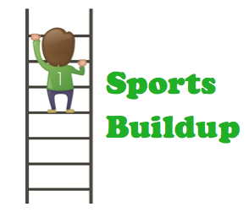

App Icon
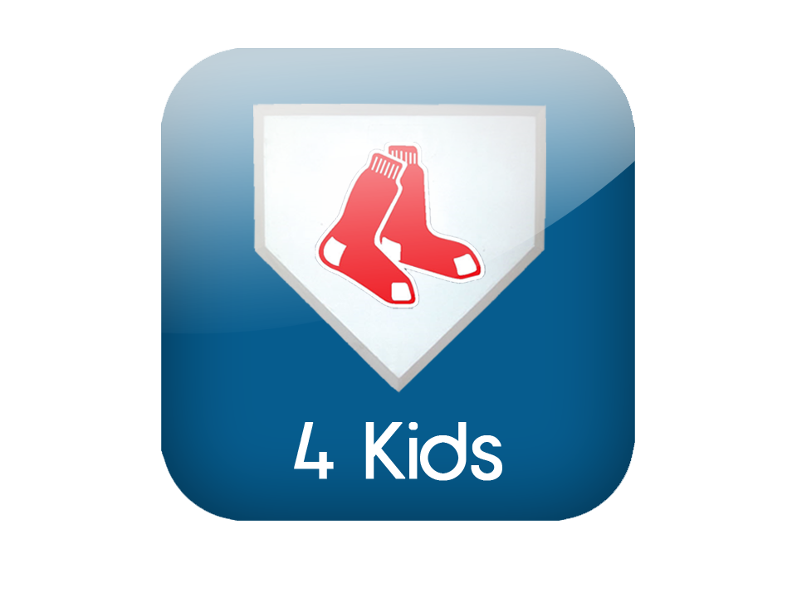

Splash Screen (Sample)
