Lusus LLC
Executive Summary
Unleashing the True Potential of the Youth
Company Background  Business Description: Lusus is structured as a partnership between Eli Butters and Brandon Murillo and a Limited Liability Corporation (LLC) in order to protect the assets of Eli and Brandon and to obtain tax benefits. Lusus provides the creation and management of one Fanbase 4 Kids mobile application for professional sports teams in order to help the team obtain younger fans while encouraging children to become more physically active.  Business Model: One unit of sale is one Application Package, consisting of the creation and support of a custom mobile application for the team called Fanbase 4 Kids, paid for by a professional sports team. Fanbase 4 Kids is a mobile application that promotes the team to children nationwide while encouraging them to become more active.  Mission Statement: At Lusus LLC, we aim to promote the widespread adoption of a healthier lifestyle through increased interest and participation in physical activity, including causal, recreational, and professional sports.  Market Opportunity  Opportunity: Today’s society recognizes that high child obesity rates and lack of physical activity have become a major issue. Coincidentally, professional sports teams are always looking to obtain younger fans. Fanbase 4 Kids solves both of these problems, by building up fans for professional teams while getting children to adopt a more active and healthy lifestyle. | Contact Information  Eli Butters and  Brandon Murillo  (860) 695-9450  sportsbuildup@gmail.com  Lusus LLC  2 Pent Rd  East Hartford, CT  06118  Year Founded  2014  _____________  Investment Opportunity  $55,079.00  Annual Operating Costs*  $8,415.00  Annual Sales*  $134,400.00  Annual Profit*  $86,388.00  Return on Sales*  63.8%  Return on Investment*  155%  Breakeven Units/Month*  1 Unit  *Projected

Target Market: People who would download Fanbase 4 Kids include children or families with children ages 5 -13 with a household income of $20,000 or greater. They would be residents of the United States, although more highly concentrated in urban and suburban areas. They are in families that are fans of sports or download apps for their kids, and own a smartphone or tablet.
Industry Overview: The Smartphone App Development Industry is currently a $9.7 billion industry, which is expected to grow by about 22% each year up until 2017.

Leadership
Qualifications: Eli and Brandon’s qualifications for this include both of them having more than 4 years of experience in programming and web design, enrollment in Mobile Application Development and Entrepreneurship courses, lifetime involvement in sports, and connections with executives of Major League Baseball, MLB Network, NFL Network, and various professional sports teams.

Lusus LLC
Business Plan
Unleashing the True Potential of the Youth

1. OPPORTUNITY RECOGNITION & BUSINESS STRUCTURE
1.1 Business Opportunity

A health-based sports app geared towards kids is a highly viable opportunity in the United States. The average child in the U.S. between ages 5 and 13 spends 7 and a half hours in front of a screen every day. Coincidentally, professional sports teams are always looking for ways to build up a strong fanbase for the future by appealing to this younger generation. Lusus is looking to solve this problem through its mobile application project Fanbase 4 Kids. Fanbase 4 Kids encourages children to participate in physical activity by earning achievements and prizes, while getting them more involved as a fan of a specific sports team through team news and trivia.

1.2 Type of Business

Lusus will be a service business creating mobile applications for professional sports teams looking to obtain fans of a younger age while promoting their health.

1.3 Type of Business Ownership

Lusus will be a Limited Liability Corporation, owned and operated by partners Eli Butters and Brandon Murillo. The LLC Status will protect Eli Butters’ and Brandon Murillo’s personal assets and allow the company to enjoy some tax benefits.

1.4 Mission Statement

At Lusus LLC, we aim to promote the widespread adoption of a healthier lifestyle through increased interest and participation in physical activity, including causal, recreational, and professional sports.

1.5 Social Responsibility

Lusus is always looking to increase the health of the younger generation through decreasing childhood obesity rates, increasing interest and participation in physical activity, and promoting the adoption of an overall healthier lifestyle.

Furthermore, after one year, Lusus plans to contribute 5% of its yearly net profit to charities promoting children’s health.

1.6 Qualifications

Eli Butters and Brandon Murillo both have more than four years of programming and web design experience. Both have also taken an Entrepreneurship course and a Mobile Application Development course. They have had lifetime involvement in various sports, and have strong connections with executives of Major League Baseball, MLB Network, NFL Network, ESPN, and various professional sports teams.

Eli and Brandon have many personal characteristics and skills that are particularly valuable in this business venture, including: a passion for sports and technology, organizational skill, creativity, sociability, professionalism, and knowledge of the sports world.

2. MARKET RESEARCH
2.1 Market Research

The smartphone application development industry is growing rapidly, with an estimated 1.2 billion customers in 2012 and an expected 4.4 billion customers by 2017. The smartphone application development industry currently makes an estimated $9.7 billion per year, which is expected to increase with the number of customers.

Of the 314 million residents of the United States, about 30 million are between the ages of 5 and 13 years old, which is the size of our target market. Based on our survey, about 50% of children or families with young children would be interested in downloading a Fanbase 4 Kids application, although to be conservative, we estimate about one third would download one, coming to a market size of about 10 million potential customers.

2.2 Target Market

Demographics: Ages 5-13 male or female with household incomes of over $20,000

Geographics: Residents of the United States, higher concentration in urban and suburban areas

Psychographics: Members of families that are fans of or involved in sports, like to win prizes and show off their accomplishments

Buying Patterns: Members of families that own at least one smartphone or tablet, members of families that download apps for their kids

2.3 Competitors

Due to the uniqueness of Fanbase 4 Kids, Lusus currently has no direct competitors.

Indirect competitors of Lusus primarily include Team Stream and NBA Game Time. Both of these mobile applications work to increase the knowledge that pre-existing adult fans have of the league or their favorite teams, whereas Fanbase 4 Kids apps work to create new, young fans while getting them physically active.

2.4 Competitive Advantage

- Connections – Major League Baseball, MLB Network, NFL Network, ESPN, and various professional sports teams
- Ensured Publicity – Teams advertise the app themselves, because the application promotes the team
- Health-Based – Has an obvious social benefit that appeals to adults and children alike

2.5 Business Growth

Kids today lack fitness, and have become increasingly less involved in physical activity, resulting in a high rate of child obesity. As a result, more and more people are looking for ways to lower obesity rates, especially in kids. Coincidentally, professional sports teams are always looking for new ways to obtain fans of a younger age, which they need in order to have a strong group of fans for the future. With Fanbase 4 Kids, we can help both parties by decreasing childhood obesity rates and promoting professional sports teams to the younger generation at the same time.

In order to make Fanbase 4 Kids operational, an application prototype would need to be completed in full, and then the idea would need to be pitched to professional sports teams. Once a team agrees to partner with us, we would develop the application for their team, and eventually release it on the app stores. By this time, other teams will be more interested in Fanbase 4 Kids due to it already having been successfully implemented, at which point we would begin working with these other teams to build more Fanbase 4 Kids apps.

2.6 Challenges

A major issue in the mobile application development industry is the low rate of successful apps. In fact, an estimated 60% of all iOS apps fail to make a profit for the developer. While Fanbase 4 Kids is not in threatened to fall into this category, this is fairly common knowledge among those who frequent the app stores. Due to this, one of the biggest challenges Fanbase 4 Kids may face is convincing professional teams that the application line will not fall into this category.

One of the barriers Lusus must face while implementing Fanbase 4 Kids is the lack of experience Eli Butters and Brandon Murillo have as actual mobile application developers. To overcome these obstacles, both plan to take more programming courses in college in order to build their skills and knowledge for the development process.

3. FINANCIAL INFORMATION & OPERATIONS
3.1 Definition of One Unit

3.2 Production Process

Description of Process Steps
- Development of application prototype
- Pitch to professional sports teams
- Development of application package for specific professional sports team
- Implementation / release of application
- Moderation / support for application
- Repeat Steps 2-6

3.3 Variable Expenses

Materials
Material Description | Bulk Price | Bulk Quantity | Quantity per Unit | Cost per Unit
Travel Expenses | $N/A | N/A | 1 | $1,000.00
Total Material Costs per Unit |  |  |  | $1,000.00

3.4 Economics of One Unit

Economics of One Unit
Selling Price |  | $10,000.00  $0.40 per DL
Cost of var. materials exp. | $0.00
Cost of labor | $500.00
Other variable costs | $1,000.00
Total COGS/ COSS |  | $1,500.00
Contribution Margin |  | $8,500.00

3.5 Fixed Expenses for One Month

Fixed Expenses | Total: $792.00
Hosting Server | $300.00
Salaries | $200.00
Insurance | $35.00
Utilities | $25.00
Advertising | $25.00
Depreciation (Equipment) | $108.00
Apple Developer | $99.00

3.6 Income Statement for First Year of Operations

A | REVENUE | selling price × units sold |  |  | $134,400.00
B | Gross Sales | selling price × units sold | $134,400.00
C | Sales Returns | selling price x units returned | $0.00
D | Net Sales | B – C |  |  | $134,400.00
 | VARIABLE EXPENSES
 | Costs of Goods Sold
E | Total Variable Expenses | E |  |  | $1,500.00
F | CONTRIBUTION MARGIN | D – L |  |  | $8,500.00
 | FIXED OPERATING EXPENSES
G | Hosting Server | cost of hosting server × 12 months | $3,600.00
H | Salaries | cost of salaries × 12 months | $2,400.00
I | Insurance | cost of insurance × 12 months | $420.00
J | Utilities | cost of utilities × 12 months | $300.00
K | Advertising | cost of advertising × 12 months | $300.00
L | Depreciation (Equipment) | cost of depreciation × 12 months | $1,296.00
M | Apple Developer Fee | cost of Apple developer fee x 1 year | $99.00
N |  | G + H + I + J + K + L + M |  |  | $8,415.00
O | PRE-TAX PROFIT | F – N |  |  | $107,985.00
P | Taxes (20%) | O × 0.20 |  |  | $21,597.00
Q | NET PROFIT | O – P |  |  | $86,388.00

3.7 Start-up Investment

Item | Why Needed | Cost
Computers | Application Creation/Moderation | $7,000
Additional Software | Application Creation/Moderation | 3,000
Custom User Interface | Application Feature | 12,000
Activity Feed | Application Feature | 4,500
User Profiles | Application Feature | 4,500
Dashboard | Application Feature | 4,500
Search | Application Feature | 4,500
Task List | Application Feature | 2,750
User Privacy Settings | Security | 2,750
Approval / Moderation | Security | 6,500
 | Total Startup Expenditures | $52,000
 | Emergency Fund | $1,000
 | Reserve for Fixed Expenses | $2,079
 | Total Startup Investment | $55,079

How much of this start-up investment can you afford to pay yourself? __$10,000.00__

How much of the start-up investment will you need to finance? (Total Start-up Investment- What you can afford to pay) __$45,079.00__

3.8 Financial Ratios

ROS: Return on Sales
$85,488.00 | = | 63.8% | ≈ | $0.63
$134,000

ROI: Return on Investment
$85,488.00 | = | 155% | ≈ | $1.55
$55,079.00

Breakeven Units (Monthly):

Fixed Monthly Expenses |  | $792.00 | = | 0.09 | ≈ | 1 units
Contribution Margin |  | $8,500.00
4. MARKETING & SALES
4.1 Marketing Plan

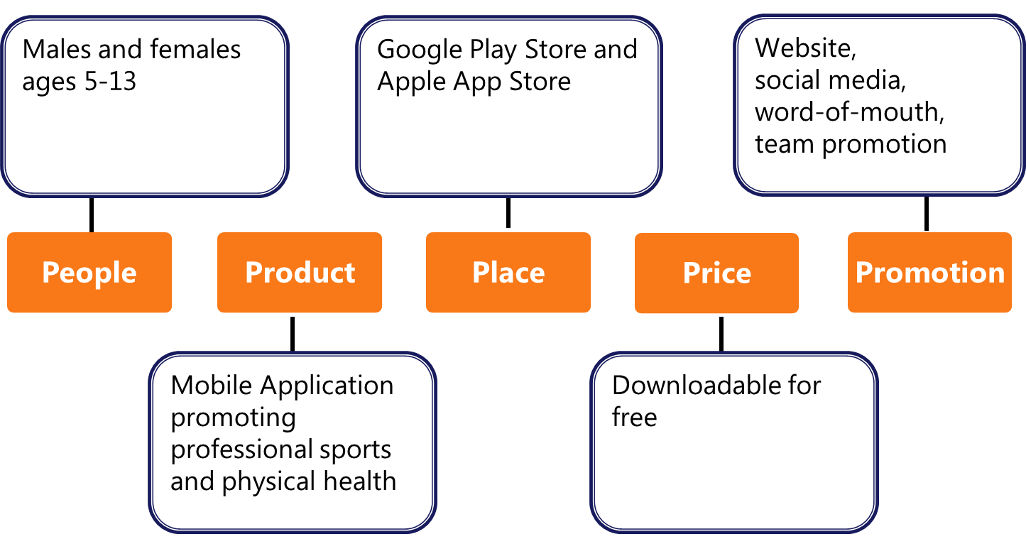

4.2 Promotion

To promote Fanbase 4 Kids applications, a great deal of the advertisement will be done by the professional sports themselves, because the app in turn promotes their team. This promotion may consist of advertisements or QR codes around their stadiums, commercials, and promotion by television hosts, radio hosts, and athletes. Lusus will also promote the Fanbase 4 Kids applications using social media including Facebook, Twitter, and Instagram, and potentially using ads online or within the app stores themselves. These promotional methods will be effective for reaching our target market because it will reach people who have a pre-disposition to be a sports fan, as well as those who regularly use mobile devices.

4.3 Sales Methods

The overall selling strategy for Fanbase 4 Kids is to appeal to the target market by offering them the chance to win prizes, learn more about sports, and have fun, while offering their parents an opportunity to get their kids more physically active and contribute to the improvement of their child’s overall health.

4.4 Sales Estimates

