Can You Spot the Hidden Images in These Famous Logos?
You’ve seen these famous logos countless times on billboards, passing by on trucks, and at the grocery store, but there is more to them than meets the eye. If you take a closer look, you will find that these recognized logos have hidden images and messages. Check out these inventive designs that cleverly use white space and optical illusions to display subliminal messages.
FedEx
Tostitos
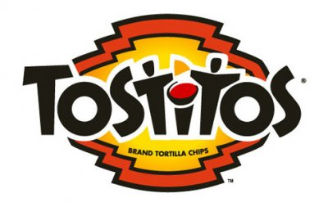
Do Subliminal Messages Really Work?
Le Tour de France
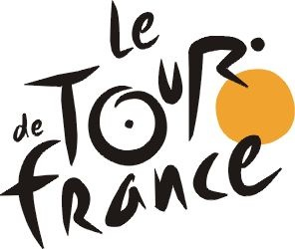
Amazon.com
Hershey's Kisses
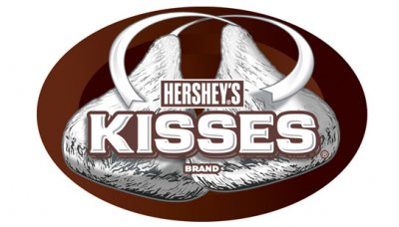
Toblerone
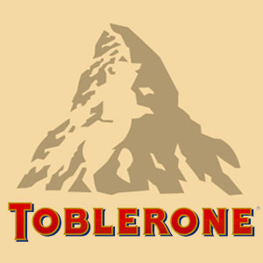
The Funniest News Bloopers
Big Ten
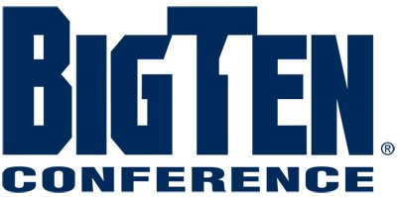
This Year's Wackiest College Courses

Northwest Airlines

Baskin Roberts

