Opportunity Recognition/Innovative Concept:
Every day, almost 30 people in the United States die in motor vehicle crashes that involve an alcohol-impaired driver. This amounts to one death every 48 minutes. The annual cost of alcohol –related crashes totals more than $51 billion… Along with these fatal statistics the State of Connecticut passed new and stricter DUI laws that will affect many drivers with immediate loss of license, larger fines and penalties, jail time, and ignition interlock device put on your vehicle. We looked at this data and have come to the conclusion that thankfully there are effective measures that can help prevent injuries and deaths from alcohol- impaired driving and our company is one of them.
Current Conditions
The state Department of Transportation regulates Connecticut's 90 taxi companies, and has assigned 11 of those companies to Greater Hartford as their primary territory. Those 11 companies have 114 total registered cabs, said Dennis J. King, manager of the regulatory and compliance unit of the DOT's bureau of public transportation, which regulates taxis. For the most part short fare rides are the most undesired and a few years ago, the state DOT received a rash of complaints from people after taxi drivers in downtown Hartford refused to take them on short rides. Our company will seize this opportunity to fill that need with its pedicab service as well as local cab service. The idea to service our community is what we have in mind.
Service Description
Happy Hour Cabby™ a Greater Hartford CT based company, whose mission is to provide reliable, timely, and safe transportation services to our community. Our goal is to decrease the percentage of DUI arrests in our community and thus saving lives. The company will establish its presence in the industry by its new and innovative way of helping with the on- going problem of drinking and driving. Happy Hour Cabby™ has been born through the effort of young adults who have chosen to make a difference in their life time.
Happy Hour Cabby™ a non-profit organization will provide transportation services during specific hours of the week using the latest equipment and technology to facilitate the travel of individuals in and around the Greater Hartford Area. The company’s services show that we are an innovative, forward thinking company that recognizes the need to adapt with ever-changing customer needs, new more stringent DUI laws, a need for an environmental conscious society, and the new technology advances that will lead us into the future. At Happy Hour Cabby™ our philosophy is one that emphasizes adaptability, service to others, and a realization that effective communication and a pro-active approach is important to the solution of this problem. The company also realizes, in an environment where there are more cars on the road than ever, the importance of this service has never been greater.
How it works
Step one will be to get the word out about the yearly membership offer. Customers will purchase a yearly membership for a $50.00 fee plus a onetime charge of $5.00 for the RFID (radio frequency identification card) card that will be used for ride access and payment. Those that purchase the membership will receive the following: free pedicab rides, 40% off zone 1 cab fares, 30% off zone 2 cab fares, 20% off zone 3, discounts at partner restaurants and hotels, and next day free ride back to vehicle if left in the city. Our pricing structure for cab service is centered on a simple price based on which zone you are being picked up or dropped off from. The prices for the zones are as followed: zone 1 $5.00, zone 2 $10.00 and zone 3 $15.00. An addition two dollar per person charge will be added for additional riders. Our pedicab service will have a flat rate of $1.00 per ride. We will have special coupons for patrons of our sponsoring restaurants and hotels.
Logo Designs/Branding:
The following are design concepts created by our design staff. The final designs will be worked out. We just wanted to show the different artwork concepts.
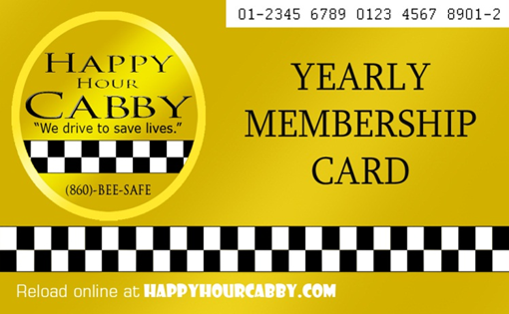
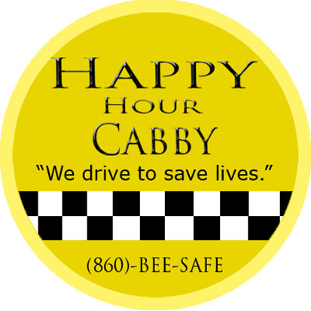

Logo Yearly Membership Card

Quick Response Code Slogan
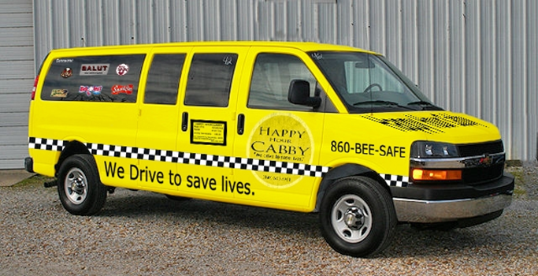

Larger Cab Design
Defend Your Innovation
Our business idea is to create a non-profit organization working with local businesses to set up a safe, reliable, and timely transportation service for the Greater Hartford Area. We will provide a three season in city local pedicab (bicycle cab) service and also provide a full transportation service specifically designed for the weekend crowds at a price that cannot be beat. We are taking a pro-active approach to the problem of driving and drinking and thus helping to save lives. The company’s strategy is to build a reputation as a respected and responsible alternative to everyday transportation needs. We will continuously monitor the laws, work on our technology needs, and build on our sustainability foundation.
Objectives
- Educate and motivate people to do the right thing
- Support for MADD and SADD
- Build a cliental base that will buy a yearly membership
- Pursue an aggressive marketing campaign to create public awareness
- Galvanize the community for support
- Deliver a safe and reliable transportation service
Highlights of Happy Hour Cabby:
- Pedicabs will provide green, people-powered transportation to residents and visitors within Hartford shopping and entertainment district
- Relationships with MADD and SADD
- Debit and credit card system for convenient payment processing
- Radio Frequency Identification for ease of identification. Members will be issued a RFID card which kept on their person will be activated when they enter the vehicle.
- IPads and smart phones for all vehicles for GPS and communication purposes
- Strategic relationships will be reached with restaurants, hotels, and entertainment establishments
- Reasonable flat rates for cab service and simple priced pedicab service within city
- Use of hybrid vehicles to maintain the green theme

Industry
Our industry is a 10 billion dollar industry. There are approximately 171,000 vehicles licensed as taxicabs in the United States. Most of those taxicabs are operated through 6,300 taxicab organizations. These taxicab organizations differ in many ways; how they are organized (privately held companies, driver owned, cooperatives, etc.), their ability to provide comprehensive, community-wide taxicab service, and the number of taxicabs they operate. Although we are a bit of a hybrid to this type of service we feel there is a definite need for our innovative transportation service. The Greater Hartford Area has a population of approximately 3 million people, our target market, male and females, 21 or older which is 65% of the 3 million which gives us about 1.9 million people. Our potential market is projected to be 1% of the target market.
Market Research
Our first step in this process is to define our target market and the best way to define our market is to conduct a survey. We want to find out where people live, why they come to the city, how often they ate out, are they business travelers, and how many times they drank and drove etc. With the data we want to create a marketing message that would give us a unique selling position that would answer the question of why would potential customers choose our transportation services.
It is our hope that our research will show that our key to success would be that we are able to meet these market needs:
- Reliability
- Convenience
- Professionalism
- Cost effectiveness
- Ability to reach our customers on an emotional level
- Safety value
We are projecting to capturing 1% our target market or 9,000 people who will buy a yearly membership.
Our next task will be to reach out to local business to see their reaction to the business idea and could we foster a business partnership with these businesses. We will contact many of the following types of businesses:
- Restaurants
- Hotels
- Banquet facilities
- Entertainment facilities
- Local businesses (Aetna, The Hartford, Travelers, United Technologies)
- Local, state and federal government

Business Growth
We feel there would be a need for this kind of service in any metropolitan district in the country. The Transportation Appropriations Act originally enacted in 2000, tied federal highway construction funding to the lowering of the minimum threshold required to be found legally drunk. By July 2004, all 50 U.S. states and the District of Columbia passed laws that lowered blood alcohol concentrations (BAC) from 0.10 to 0.08 percent. Along with this Act came tougher laws and restrictions from the individual states. This business concept could be easily franchised in these areas and make for a safer community for the city, its citizens, and its businesses.
Marketing Pitch
Come one come all…let me introduce you to an innovative franchise opportunity. Happy Hour Cabby™ a Greater Hartford CT based company, whose mission is to provide reliable, timely, and safe transportation services to its community is ready for distribution. Our goal is to decrease the percentage of DUI arrests in our community and thus saving lives. Having developed a service that transforms lives and communities, Happy Hour Cabby™ is about doing something right for a community. Imagine a way to bring city government, city businesses, and citizens together to provide safety for all. We will be a model business for other urban areas that care deeply about the well-being of its people. The idea to service our community is what we have in mind.
Customers
Happy Hour Cabby’s target audience will have the following characteristics:
- People who want to do the right thing
- People who care about the environment
- People who like technology
- People who like to eat out

Demographics: Our focus will be on males and females age twenty-one and older in any income level who are motivated to use our service because of its ease, cost effectiveness, safety, and overall quality that will be associated with our services.
Geographics: This audience will be from the Greater Hartford Area at this time, we plan to expand this enterprise to any urban community.
Psychographics: People who like to participate in the city life and the activities offered (Restaurants, hotels, night-clubs, athletic and music events and social clubs). People that like to have a good time on the weekends.
Buying Patterns: Buying patterns include weekend visits to the cities entertainment and shopping district. People who like to spend their discretionary funds on entertainment activities.
Media:
We have created a commercial as well as a jingle for this project.
Team Players: Lucia Osman, Akeem Allen, Ramon Hernandez, Darin Herrera, Fatima Duric, Jannele Reyes, and Paul Stamper

