Opportunity Recognition/Innovative Concept:
Uniform Recycle is a for-profit eco friendly business that focuses on the distribution of used school uniforms. Since the evolution of second hand clothing distribution in the late 1960’s bringing about a realization that clothing that would otherwise get thrown away to fill up space in a landfill or dump will get a chance to be recycled and transferred to someone who can reuse the clothing.
Our main purpose of the business is to reduce the consumption of clothing waste by reusing and recycling school uniforms. Our products are gently used school uniforms and accessories.
With all the schools in the major urban cities in our state going with school uniforms we feel that this is a huge opportunity for us to start our franchise. We have made partnerships with established uniform providers increasing both our client base and the ability to offer additional services and growing our market control. We know that in these tough economic conditions and overall rising costs people are looking for cost saving venues. Recognizing their need at this time gives us the window of opportunity to establish our franchise.
Defend Your Innovation:
After careful research we have found that our major advantage is the cost saving features we offer our customers in these tough economic times. The average family size in Connecticut consists of two children making the average family contribution for uniforms being $500-$1000 per year depending on quantity of uniforms bought for each child. Multiply that by 12 years and you get a family contribution of $6,000 - $12,000. Uniform Recycle can cut the family contribution in half or more. It gives our customers a way to save money, to contribute to the green cause, and to help schools whose budgets are being cut. We don’t stop there, we will also provide easy convenient drop off and pick of the uniforms and support services that other companies don’t. We are the only uniform recycling company in the city specializing in school uniforms giving us a distinct advantage in this market.
The public can participate in the following ways:
Donations:
Families who no longer need their school uniforms (moving, school children graduate from middle schools or high schools) can donate their used uniforms to Uniform Recycle. All donations are tax deductable.

Cash Buy-back:
Families will be offered $2 for each piece of clothing (quality condition) shirt, pant, skirt, or skort and $0.50 - $1.00 for accessories.
Uniform Credit
Families will be offered $4 of credit for each piece of clothing that is given to Uniform Recycle and $0.75 – $3.00 for accessories. (The credit can be used to purchase from our used inventory or new from our partnered businesses)
Schools will be offered a small percentage for their own use for each uniform item that is collected by Uniform Recycle from their school. This will give the schools a much needed revenue stream that can be used at their own discretion. We feel that with this incentive schools will urge parents to participate in this process.
Our products and services will benefit students with easy access to their size, clean dependable uniforms, and freedom to exchange a uniform during the year if there was a growth spurt. For parents it removes unnecessary clothing from their closets, saves them on uniform cost, allows for a quick and convenient process for ordering, saves shopping time, and allows for an easy pick-up/drop-off of the uniforms. For schools, they will be able to help parents save money, promote positive harmony between schools and parents, and a cost efficient way to make additional funds for their school. For the environment, it will promote environmentally sound principles in the uniform/clothing industry, lessen the clothing waste in landfills, and allow schools to participate in the three R’s… reduce, recycle, reuse, and it gives Uniform Recycle a chance to introduce the fourth R… re-wear. A truly win-win situation for everyone involved.
Marketing Pitch:
On average, each one of us produces 4.4 pounds of solid waste each day. This adds up to almost a ton of trash per person, per year. In a state with over 3 million residents this means we generate close to 3,000,000 tons of municipal solid waste (MSW) each year. The U.S. retail clothing industry includes about 40,000 companies that operate 100,000 stores with combined annual revenue of $150 billion. This leads to a mass production on clothing, with that an accumulation of clothing waste. Eighty-five percent of unwanted clothing ends up in the landfill which averages to 112, 000 tons of clothing waste per year. What can we do?

We have asked ourselves this question and come up with the following. We at Uniform Recycle believe in the “green” philosophy. We feel that our society must unite and commit to sustaining earth’s resources and advocating environmental health. We believe that the environment is something to be aware of and worth saving. With the school systems in the major cities in Connecticut switching over to uniforms within the past five years this has added to the problem of clothing disposal. Uniform Recycle offers parents and students another option to sending their clothing to the landfill. We offer a way to recycle and reuse these uniforms. We will work closely with the schools and their population while urging parents to recycle their children’s uniforms in a bid to save the parents money and create a revenue stream for the schools while helping the environment. We are duly committed to the sustainment of our earth and will, by any means possible, succeed in our efforts to ensure environmental stability for our posterity.
Customers:
Our consumer profile by:
Demographics (Population): Adults/male and female, 25+, with school aged children in K-12
Geographic's (Location): Hartford County, especially the city of Hartford and the Hartford Public School System. (Initially…will expand in future)
Personalities: Environmentally conscious families and people who have little discretionary funds.
Behaviors: Consumers who repeatedly buy school uniforms for their children and the convenience and ease of pick-up and drop-off delivery of their products. Cost conscious shoppers.
Income: Low and middle income families.

Media:
The following links will lead you to our commercial and website (still under construction).
The website is still under construction but we hope you will get an idea of what we are doing:
http://dl.dropbox.com/u/3349714/uiniform%20recycle/media.html
Our commercial/infomercial:
http://www.youtube.com/watch?v=QuuzkyogtLk

More media that we are considering:
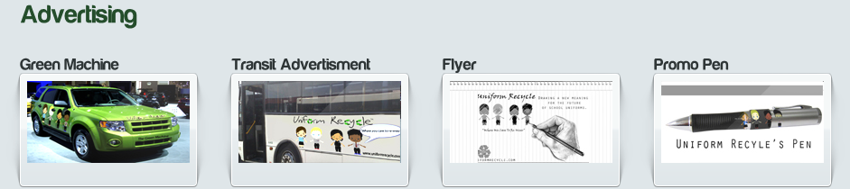

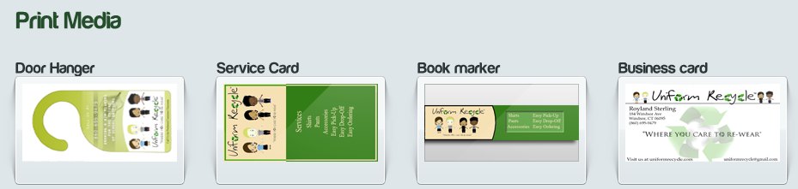

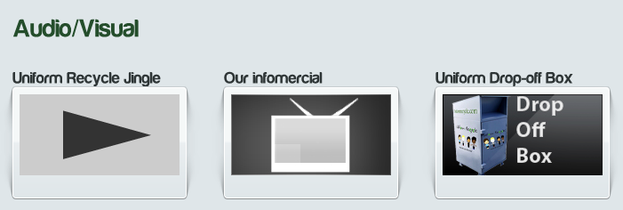

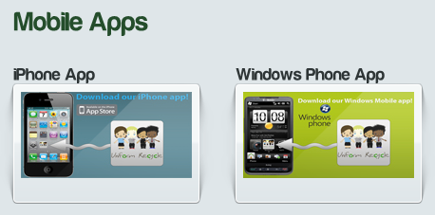

Jingle:
In order to attract the widest possible cutomer base, we expanded our promotional efforts into the auditory medium. We hope the jingle will serve as a catchy, powerful promotional device (see attached download).
Team:
The following people are members of the Uniform Recycle team:
Bryan Brooks-Gray
Royland Sterling
Bryan Gillespie
Nicole Desouza
Najee Pouncey

