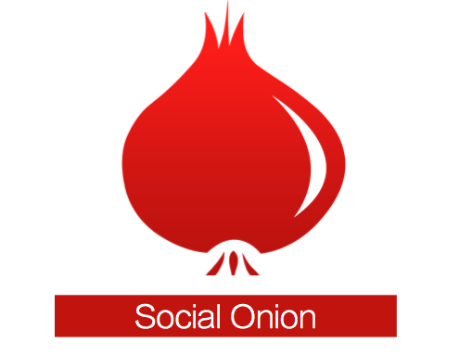

Build Relationships
Executive Summary

Company Background
Business Description: Mobile devices have changed the way we communicate with each other. These mobile devices are very portable, and most people carry their mobile phones with them almost everywhere they go. And in 2011, Google® Android™ reached 10 billion app downloads on the Android Market, which was re-branded as Google Play™. The mobile smartphone and tablet markets are expanding at huge numbers. Social Onion LLC. wants to be part of this powerful, successful, and rapidly growing industry.
Contact Information
Calvin Mahlstedt
860-8196462
CJM910@comcast.net

Social Onion
148 Old Kent Rd. N.
Tolland, CT
06084

Year Founded
2012

_____________

Investment Opportunity
$21,644.00

Annual Operating Costs*
$963.00

Annual Sales*
$31,680.00

Annual Profit*
$8,791.00

Return on Sales*
28%

Return on Investment*
41%

Breakeven Units/Month*
1396 downloads
*Projected

Official Business Name: Social Onion LLC.

Legal Structure: Social Onion LLC chose to operate as

Business Model: The definition of one unit is one app download on either the Apple App Store or Google Play. Both the App Store and Google Play will serve as the “retail store” for Social Onion’s mobile software.
Mission Statement: Social Onion is dedicated to making professional networking a simple, fast, and powerful tool for entrepreneurs and business people, so they can focus on growing their passion.

Market Opportunity
Opportunity: Address books and Contact Organizers only organize contacts alphabetically, not by importance. By using a proven system designed by Kathy McAfee, America’s Marketing Motivator, Social Onion can help business professionals such as entrepreneurs, sales, marketing, real estate professionals build and strengthen their professional network.

Target Market: Entrepreneurs, Sales, Project Management, Marketing, Legal, Real Estate age 18 and older in these professions.
Industry Overview: Social Onion operates in the Smartphone App Developer’s industry, a ~ $10 Billion industry. [Industry Size and Trends in the Market can be found in Sections 2.1, 2.5, and 2.6]

Market Research: After surveying Pathways Academy of Technology and Design’s Industry Advisory Board, (a board that includes professionals within Social Onion’s target market), 60% of the surveyed professionals responded that they are very interested in Social Onion.
Leadership

Qualifications: I as the owner of Social onion have three years experience with mobile app development business. Worked in mobile app development pilot class from National Academy Foundation, Massachusetts Institute of Technology, and Lenovo Group Ltd. I’ve worked on both Android and Adobe Flash software development. I am also currently taking Small Business Management and Entrepreneurship.

